**Part I**

Exercise 1:

a. Area between these two values of 1 standard deviation from the mean and implications of empirical rule.

🡪 The area between these two values is 0.6827, which means that there is a 68.27% chance of an event occurring from the data between the standard deviations -1 and 1. The empirical rule states that 68% of the data observed following a normal distribution falls within one standard deviation from the mean.

b. Area between 2 and 3 standard deviations from the mean and implications of empirical rule.

🡪 The area between the values of 2 standard deviations from the mean is 0.9545, which means that there is a 95.45% chance of an event occurring from the data between the standard deviations -2 and 2. The empirical rule states that 95% of the data observed following a normal distribution falls within two standard deviations from the mean.

🡪 The area between the values of 3 standard deviations from the mean is 0.9973, which means that there is a 97.73% chance of an event occurring from the data between the standard deviations -3 and 3. The empirical rule states that 99.7% of the data observed following a normal distribution falls within three standard deviations from the mean.

c. Calculating how many standard deviations above and below the mean the quartiles of any normal distribution lie using the closest available values on the applet.

- We define Q1 as the value where 25% of the data is below that value and the other 75% is above that value. For Q3, 25% of the data is above that value and then 75% is below that.

🡪 From the applet it can be observed that at -0.686 standard deviations away from the mean, approximately 25% of the data is below that value. Since the normal distribution is symmetric, Q3 would be the positive of this at 0.686 standard deviations away from the mean, with approximately 25% of the data being above that value.

🡪 Another way of approaching this is if the middle area is 50%, everything outside of it should be 50% as well and since it’s symmetric, it’s split evenly across both sides. So that means there’s 25% above Q3 and 25% below Q1.

Exercise 2:

🡪 Given mean of 69 inches and standard deviation of 2.8 inches.

a. Proportion of males less than 65 inches tall or P(X < 65).

**Command:**

**Output:**

🡪 Therefore, approximately 0.07656373 or 7.65% males are less than 65 inches tall.

b. Proportion of males more than 75 inches tall or P(X > 75).

**Command:**

**Output:**

🡪 Therefore, approximately 0.01606229 or 1.6% males are more than 75 inches tall.

c. Proportion of males between 66 and 72 inches tall or P(66 < X < 72).

**Command:**



**Output:**

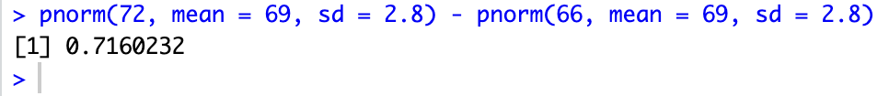

🡪 Therefore, approximately 0.7160232 or 71.6% males are between 66 and 72 inches tall.

Exercise 3:

🡪 Given mean of 69 inches and a standard deviation of 2.8 inches.

a. Calculating how tall a male must be in order to be among the shortest 0.5% of males.

**Command:**

**Output :**

🡪 Therefore, a male must be approx. 61.8 inches or 5.15 feet in order to be among the shortest 0.5% of males.

b. Calculating how tall a male must be in order to be among the tallest 0.25% of males.

**Command:**

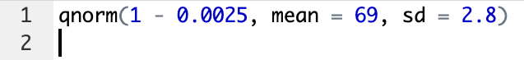

**Output :**

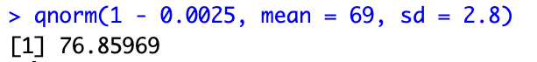

🡪 Therefore a male must be approx. 76.8 inches or 6.4 feet in order to be among the tallest 0.25% of males.

Exercise 4:

a.

🡪 Reading in and running the code

🡪 Creating a relative frequency histogram of the sampling distribution of sample proportions, and superimposing a normal curve to the histogram

**Command:**

**Output:**

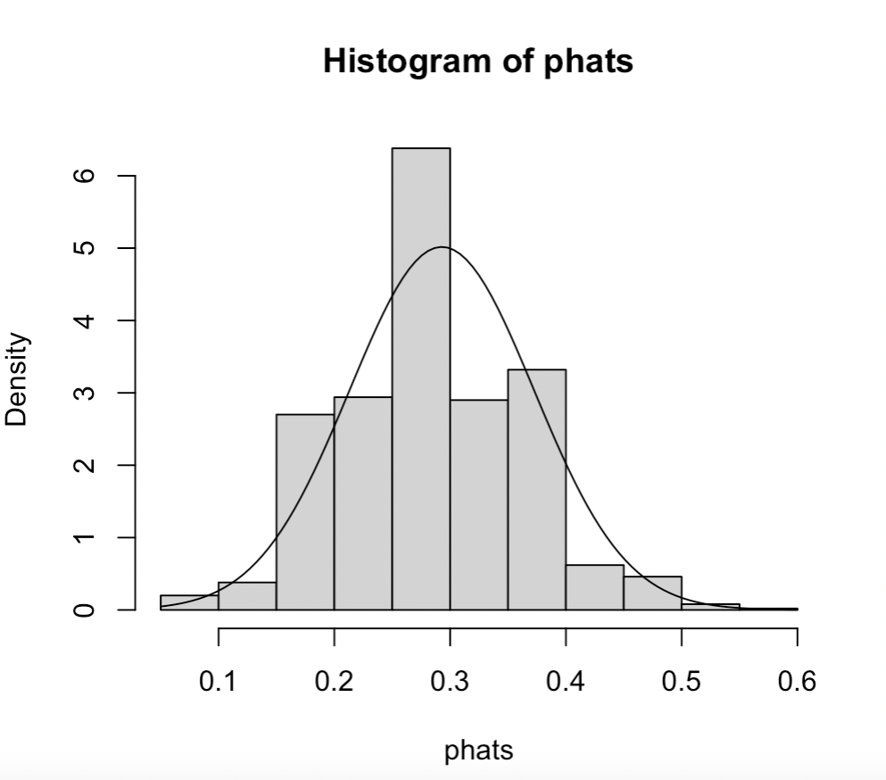

b. Calculating the mean and standard deviation of the simulated sample proportions.

**Command:**

**Output:**

🡪 Therefore, the mean and standard deviation of the simulated sample proportions respectively are 0.2928 and 0.07951963.

c. Explaining whether the simulated distribution of sample proportions is approximately normal or not.

🡪 Based on the graph, the simulated distribution is approximately normal because the histogram does closely match the normal density curve. The histogram shows a distribution that is unimodal, symmetric, and bell-shaped, which are the key characteristics of a normal distribution. This suggests that the simulated distribution of sample proportions is approximately normal. The sample size is large enough and the number of samples is pretty large so in theory it should be approximately normal as well.

d. Predicting the mean and standard deviation of the sampling distribution of sample proportions using the theory-based method, and checking how close these predictions are to the answers from Part b.

**Command:**

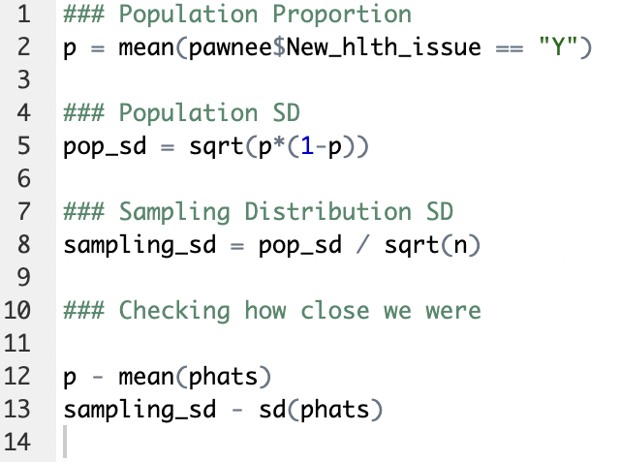

**Output:**

🡪 Checking the mean we can see that it is off by only 0.0007, so they’re very close to each other. The two sampling standard deviations, the theoretical one and empirical one, are off by 0.003 which is again pretty close. This indicates that the Central Limit Theorem is working as intended and holds true.

**Part II**

**Exercise 1:**

Given:

mean (μ) = 19.2 inches, standard deviation (σ) = 0.7 inches, and normal distribution of lengths.

a. Probability that a newborn baby will have a length of 18 inches or less.

Calculation:

Need to find the Z-score for X = 18 inches.

Z = (X – μ)/ σ

= 18 – 19.2 / 0.7

= - 1.7143

Z ≈ -1.71

We want to find P(Z < -1.71)

Using the Z-table, this is **0.04363** or **4.363%.**

Graph:

b. Percentage of newborn babies that will be longer than 20 inches.

Calculation:

Need to find the Z-score for X = 20 inches.

Z = (X – μ)/ σ

= 20 – 19.2/0.7

= 1.1429

Z ≈ 1.14

We want to find P(Z > 1.14) or 1 – P(Z < 1.14)

Using the Z-table,

= 1 – 0.87286

= **0.12714** or **12.7%**

Graph:

c. Percentage of newborn babies will NOT fit into the "newborn" size either because they are too long or too short for size between 18 and 20.4 inches long.

Calculation:

Case 1: X = 18, we know that P(Z < -1.71) = 0.04363

Case 2: X = 20.4, Z ≈ 1.71

We want P(Z < -1.71) + P(Z > 1.71)

= P(Z < -1.71) + [1 – P(Z < 1.71)]

= 0.04363 + 1 – 0.95367

= **0.08996** or **8.996%**

Graph:

**Exercise 2:**

Given:

Normal distribution N(400,60), top 30% admission, student scores 428, mean (μ) = 400, standard deviation (σ) = 60, X = 428

🡪 Need to find the Z-score:

Z = (X – μ)/ σ

= 428 – 400/60

= 28/60

= 7/15

≈ 0.467

🡪 Top 30% - Z-score attached to 30% is -0.524. We want top 30% so it is the Z-score of + 0.524 as the normal distribution curve tends to be symmetric.

🡪 Since 0.467 < 0.524, we can say that the student will **NOT get admitted.**

**Exercise 3:**

**Exercise 4:**

**Exercise 5:**

